Knowledge Building Worksheet

The building of knowledge is like building a house for living…  Where do you want your house built? Please state the topic of inquiry | topic

First, we gather the building materials…

Write down anything you know about the topic (use a separate sheet if necessary)
Listing points is like laying bricks around

Collect
Many students answer questions by listing the points they know. But can you see a meaning from the list of points easily? Bricks are just bricks if you just lay them around, no matter how many you’ve got. If you want a house, you have to put them together in such a way so that they form a firm structure.
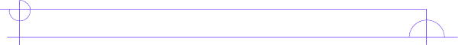
Based on the points you’ve listed above, draw a diagram to show the relationships between / within them (draw on a separate sheet if the space provided is not enough)

Forming a holistic picture of the topic is like building a house

Connect

You’ve got a house, but you can only see the beauty of the world if you go beyond the doorsteps to make connections with different parts of the community. Similarly you can only see the beauty of your discipline if you could link this topic to other topics, other subjects, other ideas. You can contribute to the community by making suggestions to improve the community. Similarly you can try to build knowledge with your creative ideas.

Based on what you’ve got above, try to generate some ideas of your own. Don’t be afraid to theorise, generalise, hypothesise, synthesise… make this part your very own creation!
Linking a topic to other ideas and creating new ideas is like integrating into the community and improving it with your contribution

Create

